User Requirements Story
FUNCTION
Description | - when a vendor (seller) is looking at a Request that has been posted by a vendee (buyer), they can directly message the vendee to ask questions, negotiate, organise delivery or pickup.  - communication/chat history will be retained  - this will work like WhatsApp or Facebook chat NOT like email  - this is NOT posting to a general forum  - this is private messaging between buyer and seller  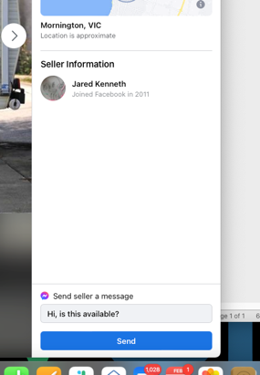
Role: | - members can communicate via a standard and simple chat program  - chat history will be maintained
I Want To: | - send messages between buyer and seller
So That I Can: | - negotiate price, organise delivery
Special Considerations: | - maintain the full chat history  - works like WhatsApp  - this is not email
ACCETPANCE CRITERIA
Given: | - chat can be launched from a Request/Posting  - members must be logged in to use chat  - vendor can send a message to a vendee  - vendee can respond  - chat messages are retained and not lost  - this is private messaging between members
When: | - message is sent  - message can be answered  - history is maintained
Then:

